ADANSI SOUTH DISTRICT ASSEMBLY

DEPARTMENT OF SOCIAL WELFARE & COM. DEV’T




REPUBLIC OF GHANA
In case of reply the number P.O. Box 1
and date of this letter New Edubiase

should be quoted Ghana, W/A
Tel: 0572-20974/5

Our Ref No: ASDA/……………………………………………….. Your Ref No:……………………. Date 30/12/2021...

ANNUAL REPORT, 2021

I forward herewith, the 2021 annual report for your perusal and further action.

(DISTRICT HEAD)

THE REGIONAL DIRECTOR
DEPARTMENT OF SOCIAL WELFARE/COMM. DEV
KUMASI
ASHANTI REGION

Cc. The DCE/DCD
Adansi South
New Edubiase

2021 ANNUAL REPORT

ADANSI SOUTH DISTRICT

NEW EDUBIASE

2021 ANNUAL REPORT
ADANSI SOUTH DISTRICT: NEW EDUBIASE

SOCIAL WELFARE UNIT
INTRODUCTION

The Social Welfare Unit during the period under review did everything possible to ensure a smooth execution of its working mandate in partnership with stakeholders in their communities creating good environment for social and economic growth in the District.
This has been possible through the three (3) core program of the Department thus Child Right Promotion and Protection, Community Care and Justice Administration.

ORGANIZATIONAL DETAILS:
No | Particulars | M | F | Total
1 | Total no of staff on pay roll | 8 | 3 | 11
2 | Total no of staff at post | 8 | 3 | 11
3 | New appointments | 0 | 0 | 0
4 | Transfers | - | - | -
5 | Postings | - | - | -
6 | Retirements | - | - | -
7 | NYEP | 0 | 0 | 0
8 | Nabco | 0 | 0 | 0
9 | National service | 1 | 0 | 1
10 | Annual leave | 0 | 0 | 0

A. JUSTICE ADMINISTRATION.
During the year under review a total number of sixty-nine(69) cases were registered and administered whiles fifty-eight were resolved amicably .

A 1. CHILD MAINTENANCE
During the period under review, Thirty-three (33) Child Maintenance cases were registered and resolved at the agency. There were Five (5) males and Twenty (28) females.
Breakdown as follows:

Particulars | M | F | Total
No of cases brought forward
No of cases registered | 5 | 28 | 33
No of cases resolved | 4 | 26 | 30
No of cases withdrawn | 1 | 2 | 3
No of cases referred to court | - | - | -
No of cases pending

A2. PARTERNITY

During the year, Seven (7) Paternity cases were recorded at the agency and resolved amecably

Particulars | M | F | Total
No of cases brought forward | - | - | -
No of cases newly registered | 4 | 3 | 7
No of cases resolved | 3 | 3 | 6
No of cases withdrawn | 1 | - | 1
No of cases referred to court | - | - | -
No of cases pending | - | - | -

A. 3 FAMILY WELFARE
During the year, seventeen (17) Family Welfare cases were registered at the Agency. Four(4) of them were males while Thirteen (13) were females.
Below is the breakdown:

Particulars | M | F | Total
No of cases brought forward | - | - | -
No of cases newly registered | 4 | 13 | 17
No of cases resolved | 3 | 12 | 15
No of cases withdrawn | 1 | 1 | 2
No of cases referred to court | - | - | -
No of cases pending | - | - | -

A .4 CHILD CUSTODY
During the year, there were seven (7) registered cases on child custody; four (4) males and three(3) females.
Particulars | M | F | Total
No of cases brought forward | - | - | -
No of cases newly registered | 4 | 3 | 7
No of cases resolved | 4 | 3 | 7
No of cases withdrawn | - | - | -
No of cases referred to court | - |  | -
No of cases pending | -

A.5 ABANDONED CHILDREN
During the year two case of abandoned child was recorded
Particulars | M | F | Total
No of cases brought forward | - | - | -
No of new cases registered
No of cases resolved | - | - | -
No of cases withdrawn | - | - | -
No of cases referred to police,Hospital,court
No of cases pending | - | - | -

A.6 GENDER BASED VIOLENCE
During the year under review,the Department of Social Welfare collaborated with DOVVSU to sensitized communities,stakeholders,teenage girls on domestic violence and gender base violence .This programme became necessary because most of the inhabitance of Adansi South are ignorant of the institutions to report cases of abuse and violence rather turn to settle it among themselves.
There is a comprehensive report of the activity carried out.
B. COMMUNITY CARE

B.1 LEAP
Thirty-Three communities benefitted from the six (6) payment cycleswith
Six Hundred and Twelve (612) beneficiaries from Akwakukrom, Odumase, Oduman, Botoku, Bepoase, Hwidiem Aggravie, Hwidiem, Kenya, Opare Kojokrom, Adansi Praso, Kojo Mankron Afedie, Bonkro, Kofi Tutu, Aboabo No 3, Nsata Mangoase, Obuobikrom, Mpentemmua, Fahiakobor, Frem, Asonkore, Aniapam, Agyarko, Kapre, Bonkro, Kweku Adu, Brepro, Ankaase. Kramokrom, Safo, Kroboline, Bronikrom benefitted from an amount of Three Hundred and Forty -Nine Thousand ,Two Hundred and Seventy- Two Ghana Cedis fifty-Four pesewas (GHȻ349272.54)

Under the LEAP 8 Targeting, Twenty-Two (22) beneficiaries are yet to access their money and information on them have been sent to the national headquarters for redress.

B.2 DISABILITY
The Department of Social Welfare and Community Development had registered and verified Two Hundred and twenty- Eight (228)Person’s living with Disability. The Department supports registered members from the Disability Fund in three thematic areas that is Education, Health and Income Generating items.
Over the period the Department has been able to support One Hundred and Thirty –Seven (137) Persons living with Disability with Income Generating Activity such as Refigeraator, sewing machine, knitting machine, Fufu pounding machine, Barbering tools, Bags of Urea, cassava grinding machine and others. Fifty -two have also received medical support and twenty -two have also received Educational support. PWDs were also sensitized on Covid 19 and its Safety Protocols during the Capacity Building section.

B3. DAY CARE CENTRES
The total number of Day Care Centres within the District are fifteen(15) with only three of them registered with the Department. The Centres are manned by 50 attendants (12 trained and the rest untrained). However, the total enrollment as at last period of visit which is in the year 2021was 2630. Below are the Daycare schools identified and monitored over the period.

Particulars | M | F | Total
No. of registered centres | - | - | 3
No. of unregistered centres | - | - | 13
No. of children enrolled in centres | 1133 | 1497 | 2630
No. of trained attendants | 3 | 9 | 12
No. of untrained attendants |  |  | 38

LOGISTICAL SUPPORT.
Though clearly stated in the Assembly’s approved budget, support earmarked for the agency has never been released, an omission that negatively impacts the effective execution of the agency’s mandate and threatens the very survival and existence of the Agency at the district level.

CHALLENGES
The major problems facing the agency range from Funding to Logistics. Details outlined below:

- The major problem facing the department is inadequate funding. The Assembly has for some time now not been able to support the agency, to effectively execute its mandate, though the agency’s annual budget estimate and programme of activities have been factored into the approved budget for the assembly.
- Vehicles to move around especially in emergency cases about children is a problem for the Department.
WAY FORWARD
- Due attention be given to problems/challenges outlined above.

PLANS FOR THE NEXT QUARTER
The agency will continue to run activities under the core programs mandated.

CONCLUSION
The department is still poised to ensure a successful implementation of all activities forming part of the agency’s mandate within the District. In spite of all difficulties, staffs are poised to work through to ensure the reality of achieving a better Ghana agenda for all.

COMMUNITY DEVELOPMENT UNIT

OBJECTIVES: To seek an improvement in the socio-economic well-being of rural, urban and deprived communities.

WORKSHOPS/SHORT COURSES/SEMINARS: Five workshops were attended by staff of the Department during the year under review.

PLANNED TARGET:

ADULT EDUCATION / MASS MEETINGS DISCUSSIONS:

MASS MEETINGS: The staffs were supposed to undertake Seventy-one (71) Mass Meetings in sixty-Eight (68) selected communities with an audience target of Three Thousand, Nine Hundred (3900) for the communities and schools.

STUDY GROUP DISCUSSIONS: To organize Twenty-Five (25) Study Group discussions in Twenty-Five (25) communities with an audience of one Thousand,Six Hundred and Fifty( 1650) consisting of opinion leaders, chiefs, queen mothers and unit committee members.

WOMEN’S WORK:

HOME SCIENCE: To train ten (10) women’s groups with an audience target of Three Hundred (300). Income generating activities such as powder making, pastries, soap making are to be undertaken and to develop their talents in order to improve their standard of living.

EXTENSION SERVICE: The Department aimed to work with philanthropists, other Departments, Government and Non-Governmental Organizations to help improve the standard of living and well-being of the people in the District.

ACCOMPLISHMENT:

WORKSHOP: During the year under review, there were Five(5) workshops attended by the Department.

ADULT EDUCATION

MASS MEETINGS; sixty-three (63) Mass Meetings were held in Thirty-Eight (38) communities with total audience of Two Thousand Five Hundred depicting One Thousand Six Hundred (1600) females and Nine Hundred males were in attendance. Topics treated were as follows.
- Effects of Teenage Pregnancy
- Effects of Child Labour
- Education on Child Online Abuse
- Education on Covid 19 and its Protocols
- Education on Child Protection Issues

A tabular representation in appendix A
STUDY GROUP DISCUSSIONS; Twenty-three (23) Study group discussions were held in Twenty-Four (24) communities with an audience of Three Hundred and Ninety-Four (394) depicting One Hundred and Seventy -one (171)males and Two Hundred and Twenty-Three (223) females. The following were sensitization topics treated.
- Education on Covid 19 and its mandated Protocols
- Education on Communal labour
- Education on Child Protection issues
- Education on Effects of Child Labour
These activities were carried out in a home visit manner due to the covid pandemic that did not allow large cloud meetings. A tabular representation in appendix B

VARIANCE; The Department was able to meet all its planned target for the year under review
HOME SCIENCE: During the year, Seven (7) women groups were trained in income generating activities such as bar soap making, pastries and bead to develop their talents in order to improve their standard of living. We also advised them to support their families in educating their children and also use the monies that will be accrued from the soaps business to support their children’s education. APPENDIX C depicts it the various community women,s groups that were trained and also sample pictures to show the demonstration.

HOUSE TO HOUSE VISITATON; during the years three female staff, Mrs. Emma Owusu Britwum, Mrs. Priscilla Akado and Rhoda Dwamena Bawuah visited some women in their communities. Parents were advised to keep their environment clean, weed around their houses, clear choked gutters and burry empty containers. Pregnant women were also advised to sleep under treated mosquito net to prevent themselves from mosquito bites which cause malaria. We also advised them to take good care of their teenage girls in order to prevent them from teenage pregnancy.
VARIANCE: Through our education and advice most women were able to initiate projects themselves to generate income to support their families.
EXTENSION SERVICE:
EDUCATION: During the year Mrs. Emma Owusu Britwum a member of District Education Oversight Committee (D.E.O.C.) and Mr. Wiafe Richard, a S.D.O in collaboration with education service staff visited nine (9) schools on the programme, MY FIRST DAY AT SCHOOL. During the visit, pupils were advised to take their studies seriously, should be disciplined and to avoid absenteeism and lateness to school.

WATER AND SANITATION: During the year, District Water and Sanitation Team (D.W.S.T) visited ten (10) communities who are the beneficiaries of the on-going Government of Ghana and Cocoa Marketing Board (GOG/CMB) borehole project. As part of the project, Water and Sanitation Management Teams (W.S.M.Ts) are to be formed in each of the beneficiary community to manage the boreholes and sanitation issues.
The visit therefore aimed to organize all the ten (10) beneficially communities in order to select committed community members to be part of the WSMT. We also educate the WSMTs on water and sanitation processes, the roles and duties to be performed by each member of the team.
DISTRICT ASSEMBLY ACTIVITIES: During the period under review, the Department collaborated with the District Assembly and participated fully in the organization of the 2020 Farmers’ day celebrations. The department was duly represented in all meetings organized by the Assembly.

NUTRITION SREVICES
There was a training of food vendors and school feeding caterers in the district on the 10TH March 2021. This was to improve nutritional services being provided to the general public and school pupils. Find attached detailed report of the training exercise at Appendix D.

APPENDIX A

APPENDIX A ADULT EDUCATION (MASS MEETINGS)

PERIOD | DISTRICT | LOCATION | NO. OF MEETINGS HELD | NO. OF AUDIENCE IN ATTENDANCE |  |  | ACTIVITIES UNDERTAKEN
 |  |  |  | F | M | TOTAL | ACTIVITIES UNDERTAKEN
1ST QUARTER | ADANSI SOUTH | KOJO YENTUMI | 1 | 40 | 25 | 65 | Effects of Teenage Pregnancy  Awareness creation on Child Abuse and its Effects
1ST QUARTER | ADANSI SOUTH | KAPRE | 1 | 40 | 15 | 55
1ST QUARTER | ADANSI SOUTH | ASONKORE | 1 | 30 | 15 | 45
1ST QUARTER | ADANSI SOUTH | BRONIKROM | 1 | 35 | 25 | 60
1ST QUARTER | ADANSI SOUTH | AKWAKU | 1 | 45 | 10 | 55
1ST QUARTER | ADANSI SOUTH | OBONSU | 1 | 40 | 20 | 60
1ST QUARTER | ADANSI SOUTH | NYAMEBEKYERE | 1 | 20 | 15 | 35
1ST QUARTER | ADANSI SOUTH | AMUDURASE | 1 | 40 | 25 | 65
1ST QUARTER | ADANSI SOUTH | ANKAASE | 1 | 40 | 35 | 75
1ST QUARTER | ADANSI SOUTH | KOFI TUTU | 1 | 40 | 25 | 55
 |  |  |  | 370 | 210 | 580
2ND QUARTER | ADANSI SOUTH | KWAOSO | 1 | 40 | 15 | 55 | Education on Personal Hygiene(home vists  Education Covid on 19 and its protocols on Community Information Centers
2ND QUARTER | ADANSI SOUTH | OBOUBI KROM | 1 | 40 | 22 | 62
2ND QUARTER | ADANSI SOUTH | ODUMAN | 1 | 40 | 20 | 60
2ND QUARTER | ADANSI SOUTH | MUSA KROM | 1 | 50 | 25 | 75
2ND QUARTER | ADANSI SOUTH | BOTOKU | 1 | 40 | 20 | 60
2ND QUARTER | ADANSI SOUTH | OPARE KOJO | 1 | 40 | 10 | 60
2ND QUARTER | ADANSI SOUTH | KOJO MANKRON | 1 | 40 | 30 | 70
2ND QUARTER | ADANSI SOUTH | SUBIN CAMP | 1 | 40 | 25 | 65
2ND QUARTER | ADANSI SOUTH | SARFOKROM | 1 | 30 | 15 | 45
2ND QUARTER | ADANSI SOUTH | ASARE KROM | 1 | 40 | 15 | 55
 |  |  |  | 400 | 197 | 597
3RD QUARTER | ADANSI SOUTH | AFEDIE | 1 | 40 | 21 | 53 | Education on Covid 19 and its protocols (community information centers and Home visits)
3RD QUARTER | ADANSI  SOUTH | ADANSI KENYA | 1 | 50 | 26 | 76
3RD QUARTER | SOUTH ADANSI SOUTH | MUSAKROM | 1 | 50 | 22 | 72
3RD QUARTER | ADANSI SOUTH | KWAME AGYEI | 1 | 40 | 27 | 67
3RD QUARTER | ADANSI SOUTH | ANKAASE | 1 | 40 | 23 | 60
3RD QUARTER | ADANSI SOUTH | MENANG | 1 | 50 | 25 | 75
3RD QUARTER | ADANSI SOUTH | ABOABO3 | 1 | 40 | 20 | 60
3RD QUARTER | ADANSI SOUTH | ANIAPAM | 1 | 30 | 27 | 57
3RD QUARTER | ADANSI SOUTH | OYAN | 1 | 40 | 30 | 65
3RD QUARTER | ADANSI SOUTH | DOTOM | 1 | 50 | 24 | 74
 |  |  |  | 430 | 245 | 675
4THQUARTER |  |  | 1 | 40 | 30 | 70 | Child Protection Activities  Alternative Care Activites  Covid 19 and its Protocols  Effects of child Labour and its Protocols (community information centers and Home visit
4THQUARTER | ADANSI SOUTH | AWOROSO | 1 | 40 | 28 | 68
4THQUARTER | ADANSI SOUTH | KWAME ADU | 1 | 30 | 20 | 50
4THQUARTER | ADANSI SOUTH | TWEAPEASE | 1 | 40 | 30 | 70
4THQUARTER | ADANSI SOUTH | NSATA MANGOASE | 1 | 40 | 20 | 60
4THQUARTER | ADANSI SOUTH | WURUYIE | 1 | 40 | 20 | 60
4THQUARTER | ADANSI SOUTH | KOTWEA | 1 | 40 | 20 | 60
4THQUARTER | ADANSI SOUTH | ODUMASE | 1 | 40 | 20 | 60
4THQUARTER | EJURA | AGRAVI | 1 | 50 | 20 | 70
4THQUARTER | EJURA | OWUSUKROM | 1 | 40 | 40 | 90
TOTAL |  |  |  | 400 | 248 | 648
GRAND TOTAL (1ST – 4TH QUARTER) |  |  |  | 1600 | 900 | 2500

APPENDIX B
ADULT EDUCATION (STUDY GROUP MEETINGS)
NO. OF STUDY GROUPS | DISTRICT | LOCATION | NO. OF MEETINGS HELD |  | MEMBERSHIP |  |  |  |  | TOPICS TREATED | RESOURCE PERSON
 |  |  |  |  | F | M | TOTAL |  |  | TOPICS TREATED | RESOURCE PERSON
UNIT COMMITTEE,CHIEF& ELDERS | ADANSI SOUTH | KOJO YENTUMI | 1 |  | 5 | 8 | 13 |  |  | Effective practice of Communal Labour  Environmental Cleanliness  Sanitation issues
NANANOM,OPINION LEADERS | ADANSI SOUTH | KAPRE | 1 |  | 9 | 5 | 14
CHIEF & ELDERS | ADANSI SOUTH | ASONKORE | 1 |  | 7 | 8 | 15
UNIT COMMITTEE | ADANSI SOUTH | BRONIKROM | 1 |  | 6 | 9 | 15
WATSAN | ADANSI SOUTH | KWAME AGYEI | 1 |  | 10 | 4 | 14
UNIT COMMITTEE | ADANSI SOUTH | NYAMEBEKYERE | 1 |  | 11 | 3 | 14
UNIT COMMITTESE | ADANSI SOUTH | PRASO | 1 |  | 10 | 10 | 20
TOTAL |  |  | 7 |  | 58 | 47 | 105
2ND QUARTER, 2021
WATSAN | ADANSI SOUTH | FRANTE | 1 |  | 7 | 9 | 16 |  |  | Effective practice of Communal Labour  Child Protection Issues  Water and Sanitation | All staffs
UNIT COMMITTEE | ADANSI SOUTH | AKWAKU | 1 |  | 8 | 9 | 17 |  |  |  | All staffs
UNIT COMMITTEE | ADANSI SOUTH | MPETEMUA | 1 |  | 10 | 5 | 15 |  |  |  | All staffs
WATSAN | ADANSI SOUTH | MENANG | 1 |  | 11 | 8 | 19 |  |  |  | All staffs
CHIEF & ELDERS | ADANSI SOUTH | ASONKORE | 1 |  | 7 | 8 | 15 |  |  |  | All staffs
TOTAL |  |  | 5 |  | 43 | 39 | 82 |  |  |  | All staffs
3RD QUARTER, 2021
CHIEF & ELDERS | ADANSI SOUTH | AKWAKU | 1 |  | 10 | 5 |  | 15 |  | Effective practice of Communal Labour  Water and Sanitation issues  Sensitisation of Covid 19 and its Protocols | All staffs
CHIEF & ELDERS | ADANSI SOUTH | WURUYIE | 1 |  | 12 | 5 |  | 17 |  |  | All staffs
UNIT COMMITTEE | ADANSI SOUTH | TWEAPEASE | 1 |  | 8 | 5 |  | 13 |  |  | All staffs
UNIT COMMITTEE | ADANSI SOUTH | AWOROSO | 1 |  | 8 | 7 |  | 15 |  |  | All staffs
WATSAN | ADANSI SOUTH | KOJO MANKRON | 1 |  | 9 | 10 |  | 19 |  |  | All staffs
CHIEF & ELDERS | ADANSI SOUTH | ATOBIASE | 1 |  | 8 | 10 |  | 18 |  |  | All staffs
NANANOM &CP COMMITTEE MEMBERS | ADANSI SOUTH | APAGYA | 1 |  | 7 | 3 |  | 10 |  |  | All staffs
TOTAL |  |  | 7 |  | 62 | 45 |  | 107 |  |  | All staffs
4TH QUARTER, 2021
CHIEF AND ELDERS, OPINION LEADERS, | ADANSI SOUTH | AWOROSO | 1 | 10 |  | 10 |  | 20 | Sensitisation of Covid 19 and its protocols  Child protection Education
UNIT COMMITTEE MEMBERS AND ASSEMBLY MEMBER | ADANSI SOUTH | MENANG | 1 | 10 |  | 10 |  | 20
WOMENS GROUP | ADANSI SOUTH | KOJO MANKRON | 1 | 10 |  | 10 |  | 20
WOMENS GROUP | ADANSI SOUTH | AMUDURASE | 1 | 10 |  | 5 |  | 15
WOMEN,S GROUP | ADANSI SOUTH | KWAME ADU | 1 | 20 |  | 5 |  | 25
TOTAL |  |  | 5 | 60 |  | 40 |  | 100
GRAND TOTAL: (1ST – 4TH) |  |  | 24 | 223 |  | 171 |  | 394

APPENDIX C
(DEMONSTRATION ON INCOME GENERATING ACTIVITY)
S/N | WOMEN,S GROUP | ATTENDANCE  M F F |  | TOTAL | DEMONSTRATION | RESOURCE PERSONS
1 | AMUDURASE PALM OIL EXTRACTION GROUP | 1 | 25 | 26 | BAR SOAPS PREPARATION | MADAM  PRISCILLA AKADO
2 | KOJO MANKRON WOMEN’S GROUP(PALM OIL EXTRACTION |  | 35 | 35 | LIQUID SOAP PREPARATION | MADAM EMMA BRITWUM
3 | TONKOASE GARI PROCESSING | 3 | 27 | 30 | BAR SOAP | MADAM EMMA BRITWUM
4 | TWEAPEASE GARI PROCESSING | 4 | 32 | 36 | BAR SOAP | MADAM EMMA BRITWUM
5 | ATAASE PALM | 2 | 33 | 35 | LIQUID SOAP PREPARATION | MADAM PRSCILLA AKADO
6 | NEW EDUBIASE PALM OIL EXTRACTION | 3 | 34 | 37 | BAR SOUP PREPARATION | MADAM EMMA BRITWUM
7 | KWAME AGYEI PALM OIL EXTRACTION | 1 | 28 | 29 | LIQUID SOAP PREPARATION | MADAM PRISCILLA AKADO
 | TOTAL | 14 | 214 | 228

PROBLEMS;
- Lack of Funds to embark on demonstrations to improve women’s group.
- The department needs a computer printer to make our work easier.
- Incentives for the trekking officers.
REMARKS: Our target for the year was not fully achieved due to the numerous challenges faced which include the outbreak of Covid 19, the farming season, unfavorable climatic conditions and uneasy roads accessibility due to its bad conditions.
WAY FORWARD:
MASS MEETING: To organize Seventy-One (71) Mass meetings in Sixty-Eight (68) communities with an audience of Thirteen Thousand, Nine Hundred (13,900).
STUDY GROUP DISCUSSION: To organize Twenty-Five (35) Mass meetings in Twenty-Five (35) communities with One Thousand, Six Hundred and Fifty (1650) audience.
WOMEN'S WORK: The staff aimed at educating women in the District to improve their talents with an estimated number of One Thousand, Three Hundred and Eighty (1380) women.

APPENDIX D
A REPORT ON A TRAINING ORGANISED FOR COOKS AND CHIEF COOKS OF THE GHANA SCHOOL FEEDING PROGRAM AT THE DISTRICT ASSEMBLY HALL BY THE DISTRICT DEVELOPMENT PLANNING UNIT ON THE 10TH March, 2021.
BACKGROUND.
The Ghana School Feeding Program is one of the cardinal pillars of government’s social intervention programs. This government flagship initiative was introduced in 2004. The objective of the program is to provide the beneficiary basic school children one nutritious meal a day to enhance teaching and learning. This is to ensure that children stay in school till the closing time and do not leave school during instructional hours in order to look for food.
It is also to ease the burden of parents and promote local economic development as most of the food items are produced locally.
All caterers and chief cooks from the 32 schools benefitting from the program within the district participated. In attendance there were 45 caterers and chief cooks and 6 facilitators.
The training exercise was conducted to enable the desk officer familiarize himself with the conditions in the beneficiary schools, enlighten caterers about new additions to the program and also have the opportunity to discuss challenges faced by caterers, head teachers and management of the schools as far as the program is concerned and report for necessary action.
The training session commenced at exactly 9:53 am after a short prayer by Madam Comfort Akowuah. Afterwards, the SHEP coordinator, Mr. Nyame, gave a brief insight into the school feeding program. He further cautioned the new entrants (caterers) to the GSFP to update the district Development Planning officer (who also doubles as the Desk officer of the GSFP for the District) on their credentials for payment to be effected without any concern.
In the course of the training, the District Planning Officer took over from the SHEP Coordinator and begun his session on the General overview of the GSFP and how beneficial it has been to the District. He commended the Caterers for their efforts in the course of the training after admitting that, the monies allotted to them had not been enough but the quality of food being served was at an appreciable level. In order to maintain high hygienic standard in the food preparation process, the Desk officer cautioned the caterers on certain ill-food preparation practices. In the light of reducing the possibility of food poisoning, which could lead to closure of schools, the Desk officer pleaded for caterers to adhere to positive food handling measures.
The District Nutrition Officer, Mr. Michael Sarfo-Appiah, also educated caterers on nutrition and the essence of balance diet. The GSFP had been faced with numerus challenges since complaints had always been registered by the general public on under-nutrition and mal nourishment.
The nutrition officer commenced his session by engaging the Caterers to first define “Food”. Varying views were received from the caterers. Amongst these, the commonest definition given by Caterers was, “Food is any nutritious substance that people eat or drink in order to maintain life and growth”. Afterwards, the District Nutrition officer advised that, food must be eaten in the right proportion. Out of ignorance, food preparation often takes the wrong turn since vegetables for instance, which is supposed to take a short while in its preparation takes longer than expected, hence, losing its essential nutrients. In this case, education was provided for caterers to maintain high standard in the food preparation process.
In the district Assembly’s sanitation by-laws, all food vendors, pubs, spas, restaurants, drinking spots, and any venture that either sell or prepares food for the public must be screened and deemed medically fit before selling or preparing food for the public. In the light of this, the Nutrition officer advised caterers to run a widal test (samonella typhi) and must be declared fit by the Environmental Health and Sanitation Unit before preparing or selling any food related item to the public. However, it was observed that most of the caterers have either expired or no medical health certificate. The Desk officer assured Caterers to find lasting solution to the issue at hand.
The purpose of the protective clothing is not only to protect the food handler from injury but to also protect the food from contamination. The nutrition officer explained that it is common among food handlers from not adhering to precautionary measures in food preparation. In this light, the caterers were directed to desist from that for their own safety and not poisoning the foods for the pupils. Additionally, first aid box and fire extinguishers were other items that the Nutrition officer hammered on to be made readily available in kitchens in order to curb any possible accident that might sprung-out.
After the Nutrition officer was done, the SHEP Coordinator took over and laid emphasis on portion control. The main essence for the program is to provide the beneficiary basic school children one nutritious meal a day to enhance teaching and learning. It is inevitable that a hungry man is an angry man. In a bid to make the government’s flagship program beneficial to the pupils, the SHEP coordinator gave an insight into the portion of food that is supposed to be served to the pupils. Other than that, it will be an exercise in futility since the beneficiaries may not in any way benefit from the initiative. He further pleaded with the caterers to observe the following;
- Maintain high hygienic standard
- Wear protective clothing
- Ensure regular hand washing
- Ensure the presence of first Aid box
- Be screened and declared fit by a certified Medical Officer
- Ensure effective washing of vegetables before use
- Avoid adding over-left food to newly prepared ones
- Avoid serving noodles to pupils
- Avoid the use of unapproved salt
- And the need for every caterer to get a fire extinguisher in his or her kitchen.
Furthermore, on the need to manage the little resources amassed by caterers, Mr. Lawrence Arhin (a staff with the Accounts office-ADSA) painstakingly advised caterers on financial management. Since most caterers or food handlers are in the habit of purchasing food items in bits, he advised that it makes little economic sense to purchase items in bits since bulky purchasing comes with steady monetary valuation. Additionally, food handlers are to verify from different places and markets on the pricing of commodities. This in one way or the other bridge the incessant exploitation that they may be faced with, hence, saving money from a possible loss. As part of normalcy, the habit of saving and floating shares has not been a routine activity for us. In this case, Mr. Lawrence Arhin advised caterers to make extensive use of their scarce resources by floating shares in order to make the most out of the little resources they have.
After the presentation by all resource persons, the Desk officer introduced a proposed food timetable for the district. In so doing, the caterers suggested the commonest foods in their locality and the food illustrated in the table below were agreed on.
S/N | FOOD | TYPE | DAYS
1 | RICE | JOLLOF
1 | RICE | PLAIN RICE
1 | RICE | WAKYE
2 | BANKU | -
3 | AMPESIE | -
4 | BEANS | -
5 | OMO TUO | -
6 | KENKEY (GA) | -

In a nutshell, Mr. Haruna Hussein, the Deputy Director, acted in the absence of the District Chief Executive, briefed Caterers that, they are aware of the efforts being put in place by caterers to save lives and promote teaching and learning. Even though, the monies allotted to them are woefully inadequate but he commended the caterers for their dedication and assiduousness to ensure the implementation of the GSFP. Afterwards, he also asked the caterers to air their grievances concerning the program and below were some of the problems sampled from the Caterers grievances.
- They proposed increment in the amount of money allotted per head (from Ghc 1 to Ghc2)
- They have issues renewing their Medical Health Certificate
- Delay and irregular payment plans.
- Teachers complaining of portion of food given to them.
After all these complaints have been registered, the training session came to a close at 12:56pm after a prayer by Madam Comfort Akowuah.

BELOW ARE SAMPLE PICTURES OF ACTIVITIES THAT WERE CARRIED OUT WITHIN THE YEAR 2020

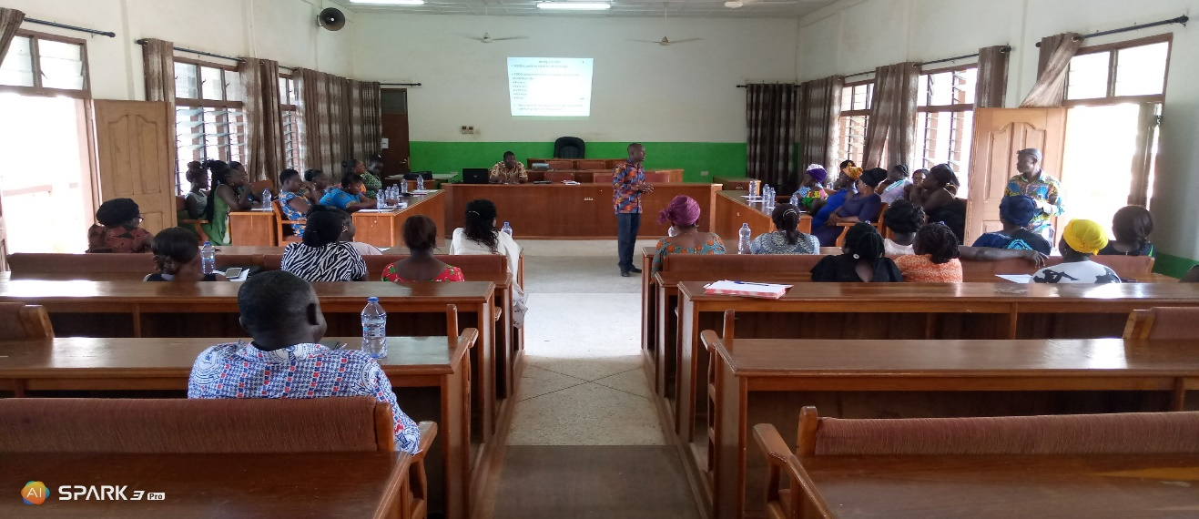
COOKS AND CATERERS AT THE TRAINING SECTIONS
14/08/2020
14/08/2020

14/08/2020

14/08/2020
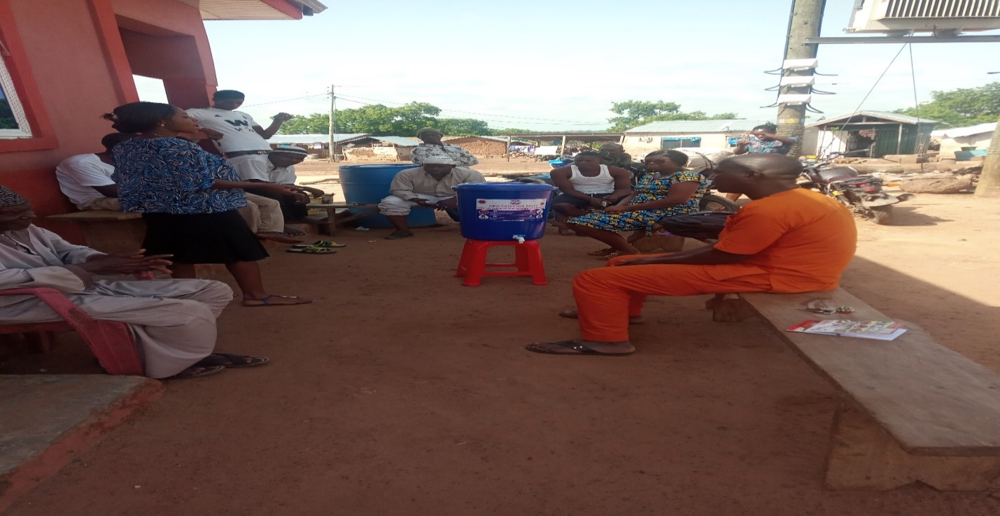
A DEMONSTRATION OF COVID PROTOCOLS AND ALSO THE USE OF THE HAND VERONICA BUCKET AT WURUYIE COMMUNITY

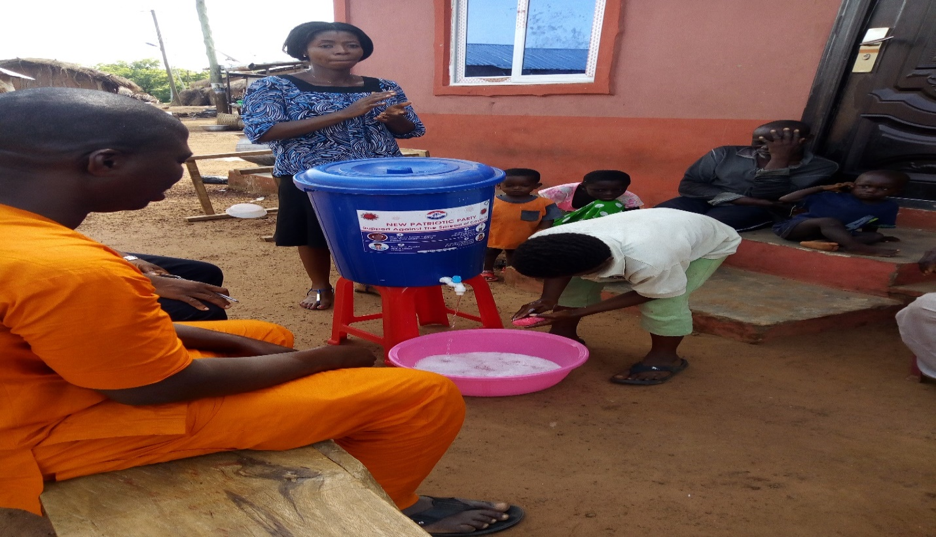

A DEMONSTRATION AOF HAND WASHING AT WURUYIE COMMUNITY AS PART OF COVID 19 PROTOCOLS

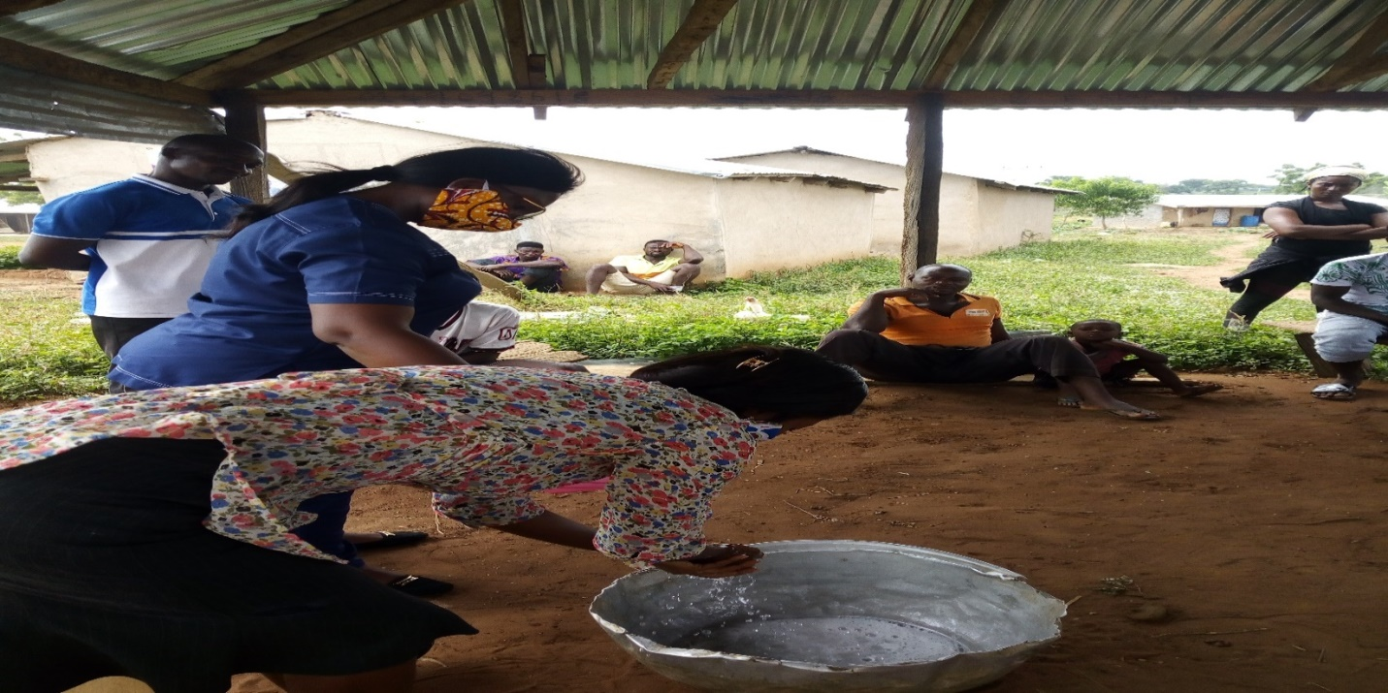

DEMONSTRATION OF HAND WASHING AT MENANG COMMUNITY

Pictures on Income Generating Activities; Soap Making
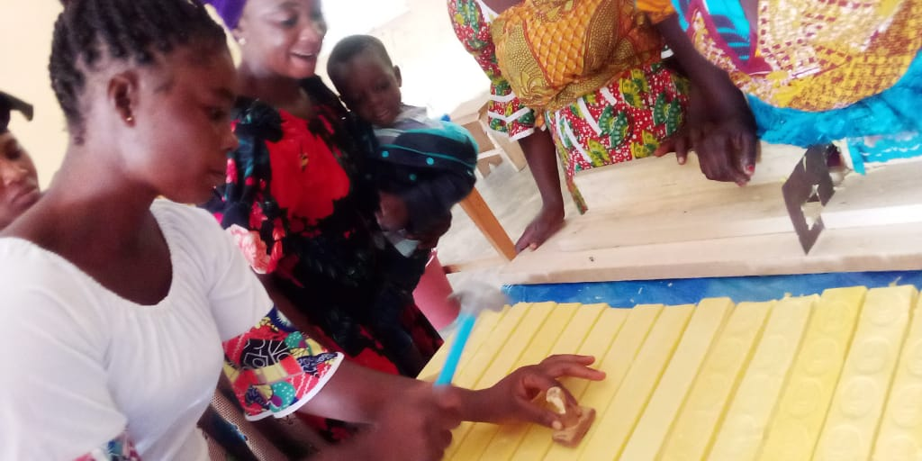
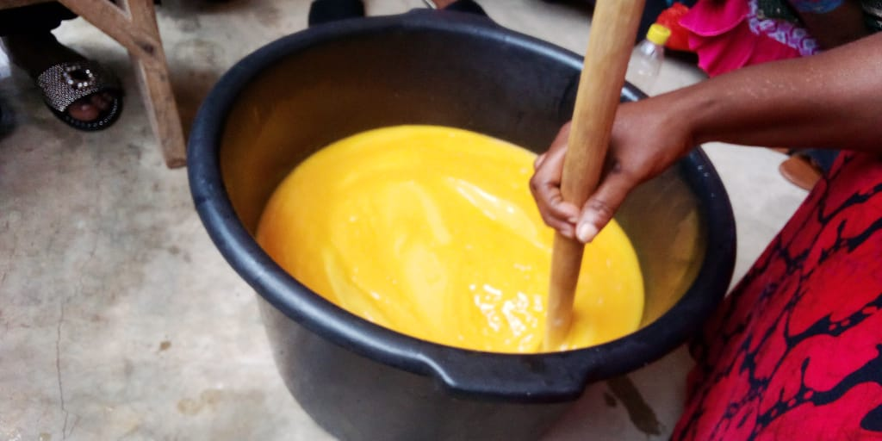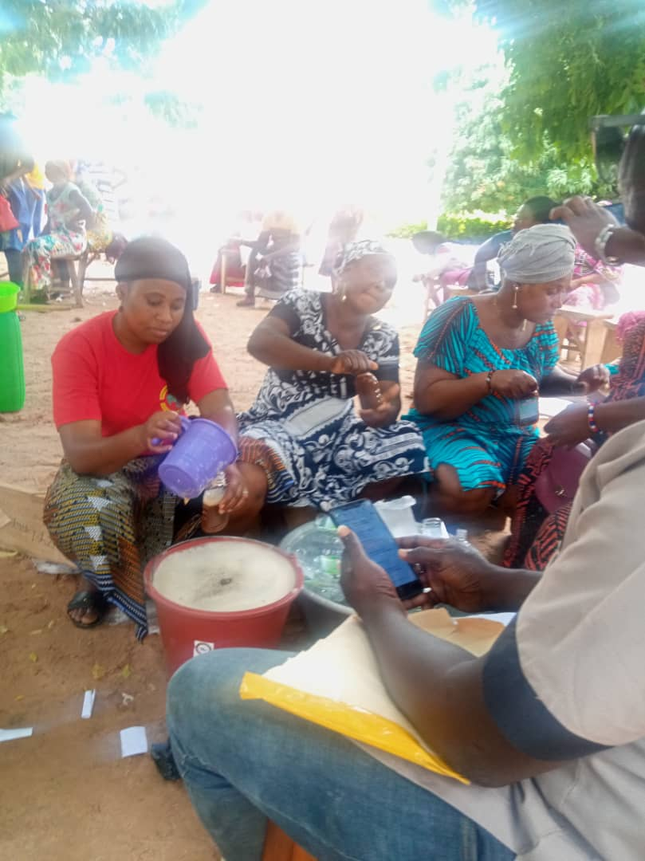



AT THE SOAP FINISHING STAGE

