ADANSI SOUTH DISTRICT NUTRITION REPORT

Annual report 2020

Nutrition Unit

DISTRICT PROFILE
This chapter explains the profile of the district taken into account the population distributions, health facilities and stakeholders in health

Geographical Location
The Adansi South District is one of the oldest districts among the forty-six (46) administrative districts in the Ashanti Region. It lies in the southernmost part of the region. It is boarded by many districts, including districts from two regions; Central and Eastern. In 2018, Akrofoum district was carved out form Adansi south district.
The district has a characteristically high ethnically mixed population dominated by Adansis, Ewes, Fantis, Akuapims, and Ga-Adangbes with an attendant cultural variability especially in attitudes and response to health risk behaviour. Also, the settlement determinants favour hamlets and cottages phenomenally at the expense of urbanization. The district stretches from one end to the other to a distance of 94 km.

Population Size and Growth Rate
According to Ghana Statistical Service and projections from the 2010 Population and Housing census, the population for the district in 2020 is 98,696. The annual growth rate in the district is about 1.97%. Below is the population distribution by sub-district;
Sub district population distribution, 2016-2018
Sub-district | 2017 | 2018 | 2019 (2.68%) | 2020 (1.97%)
Akutreso | 15721 | 16094 | 16528 | 16854
Ataase | 39435 | 39435 | 41461 | 4228
New Edubiase | 36903 | 37780 | 38800 | 39564
Total | 92059 | 93309 | 96789 | 98696

Children 0 – 11 months (4%) for EPI and Expected Pregnancies (ANC)
Sub-district | 2017 | 2018 | 2019 | 2020
Akutreso | 629 | 644 | 661 | 674
Ataase | 1577 | 1577 | 1658 | 1691
New Edubiase | 1476 | 1511 | 1552 | 1583
Total | 3682 | 3732 | 3872 | 3948

Children 6-11 months and 12-59 months for Vitamin A supplementation
 | 6-11 moths (2%) |  |  |  | 12-59 months (14.5%)
Sub-district | 2017 | 2018 | 2019 | 2020 | 2017 | 2018 | 2019 | 2020
Akutreso | 314 | 322 | 331 | 337 | 2280 | 2334 | 2397 | 2444
Ataase | 789 | 789 | 829 | 846 | 5718 | 5718 | 6012 | 6130
New Edubiase | 738 | 756 | 776 | 791 | 5351 | 5478 | 5626 | 5737
Total | 1841 | 1866 | 1936 | 1974 | 13349 | 13530 | 14034 | 14311

WIFA (24%) of the total population for Family Planning
Sub-District | 2017 | 2018 | 2019 | 2020
Akutreso | 3773 | 3863 | 3967 | 4045
Ataase | 9464 | 9464 | 9951 | 10147
New Edubiase | 8857 | 9067 | 9312 | 9495
Total | 22094 | 22394 | 23229 | 23,687

Health Service Delivery
The district has been demarcated into thee (3) sub-districts. This is to facilitate the delivery of health services. There is one (1) hospital, four (2) health centres, one (1) maternity home and four (4) Community-based Health and Planning Services (CHPS) compounds.
At the moment, there are over 200 communities and hamlets in the district with eighty-six (86) outreach points.
Names of health facilities and location
Sub-district | Health Facility | Ownership | Location
Ataase | Ataase Health Centre  Atwereboana CHPS  Hwidiem CHPS  Obonsu CHPS | Government  Government  Government  Government | Ataase  Adansi Atwereboana  Hwidiem  Obonsu
Akutreso | Akutreso Health Centre  Tweapease CHPS | Government  Government | Akutreso  Tweapease
New Edubiase | New Edubiase Hospital  Hill top Maternity Home | Government  Private | New Edubiase  Atobiase

Number of Outreach sites
Sub-district | Number of Outreach site
Akutreso | 17
Ataase | 46
New Edubiase | 23
Total | 86

A critical look at the positioning of these facilities, it is evident that few communities have relatively high access to Health services. There are a whole lot of communities and hamlets that have challenges with health care accessibility due to the bad nature of roads in the district.
The inhabitants seek health services through the following network of health facilities;
Types of health facility
Facility | Number
Hospitals | 1
Health Centres | 2
Private Maternity Homes | 1
Functional CHPS compounds | 4
Total | 8

Also prevalent in the district are Community chemical sellers, Traditional Healers, Herbalists and Homeopathic practitioners.

Schools
There are 191 registered schools in the district consisting of 146 pre-schools and Basic schools, 43 Junior high schools, and 2 Senior high school. Below is the number of schools per sub-district

Number of schools
Sub district | Number of schools
Akutreso | 45
Ataase | 96
New Edubiase | 91

Administrative Structure [Political]
The District Chief Executive is the political head with the District Coordinating Director as Administrative head and advisor to the district Chief Executive. Among the ex-officio members of the Assembly are various heads of decentralized departments representing the various district sector ministries. There are also about thirty (30) Assembly members who help in organizing or mobilizing people for development in the various communities.

Administrative Structure [Traditional]
There is one Traditional Area, named Edubiase Traditional Area with New Edubiase as its capital.

Departments in The District
Some of the decentralized departments in the District are; Ghana Education Service [GES], Social Welfare, Community Development, National Commission for Civic Education, Ghana Health Service, Ghana Ambulance Service, Internal Revenue Service, Fire Service, Ministry of Food and Agriculture [MOFA], Judicial Service, Forestry Department, Stool Lands, Ghana Police Service, Feeder Road, National health Insurance Authority etc.

Communication and Utilities

Water and sanitation
The main source of water supply in the district capital is pipe-borne water. However, surrounding communities depend heavily on harvested rainwater, boreholes, hand-dug wells and streams. Access to portable water is therefore irregular and seasonal in nature. During the dry season, rivers and streams dry up and water supply becomes a challenge. Sanitary facilities for both liquid and solid waste disposal are also inadequate in most part of the district.

Road networks
The district has a bad road network, which reduces socio-economic activities. The feeder roads into various part of the district are not tarred and many are in deplorable state. Many branch roads to the rural communities and hamlets become un-motorable during the raining seasons.

Transportation
The bulk of transportation is provided by the private sector. It is however, fairly easy to travel from the district capital, New Edubiase to other parts of the region and beyond.

Telecommunications and electricity
Cellular phones are the main means of Telecommunication. All the major towns in the district have been connected to the national electricity grid. Over 90% of the population therefore enjoy electric power. However, the power supply has been irregular and often fluctuating in intensity.

Socio-Economic Activities
There are four major occupations in the district, namely; Agriculture, Mining, Commerce, and Civil / Public Service.
Most people are engaged in farming and lumbering/sawmilling. The abundant rainfall makes rice and cocoa cultivation attractive and the district is one of the main producers. Plantain, cassava and cocoyam are produced both on small scale and commercial quantities. Other economic activities include illegal mining, lumbering and sawmilling, game hunting, palm wine tapping and Akpeteshie distilling. Trading, hairdressing, dressmaking carpentry and auto mechanics are also dominating.

Socio-Cultural activities
It is a taboo to eat fish from a river in the Edubiase Township. Taboo days are Akwasidae most inhabitants do not engage in farming activities during this day. Goat rearing in Edubiase and some other communities are also forbidden. Adansiman is a part of the Ashanti tradition and they practice matrilineal inheritance.

PRIORITIES AND SERVICES PROVIDED
Main Priorities for 2020
The Main Priorities for the Unit for the year 2020 were as follows;
- Coach and Mentor Officers to provide appropriate Nutrition Counselling Services
- Provide technical support for malnourished children
- Provide technical support for caterers and food vendors for the school feeding programe
- Improve data management by Achieving 100% accuracy, coverage &timeliness every month (On-the-job training of staff in data collection reporting and accurate Management)
- To advance nutrition surveillance system in the district and sustain growth monitoring and health promotion activities (Build capacity of staff in the usage of New Growth Charts through training and on-the-job coaching.)
- Achieve 80% Vitamin A coverage (Improve Vit A supplementation through strategic and mass supplementation)
- Improve CHPS implementation in the district

Activities carried-out within the year
As part of the implementation programme to strengthen Maternal and Child Health activities during the period under review in the district, some activities to promote the nutritional status of mothers and children 0-5 years were undertaken; amongst them were:
- Growth Monitoring and Promotion
- Vitamin A Supplementation Children (6-59 months)
- Diet Related Disease Clinics
- Nutrition/Health Education and Promotion
- Child Health Promotion Week Celebration
- Training of health staff on new MCHRB
- Monitoring and supportive visits

GROWTH MONITORING AND PROMOTION
Growth Promotion of Children (0-11 months, 12-23 months & 24-59 months)
This is an on-going program carried out within the district at the facilities and outreach points to assess the growth of children from 0 - 59 months. Children are weighed to determine their nutritional status. This helps to identify moderate and severe malnutrition cases for early intervention in order to reduce malnutrition prevalence.
All children 0-59 months who attend growth-monitoring sessions are weighed and the weight plotted on the growth chart to determine their growth trend. Monthly data on nutrition status of all children weighed are recorded.
During these sessions, weight and height compared with their respective ages are checked. Those that fall short are given appropriate counselling and where the need be some are referred to the necessary quarters for timely and appropriate intervention.
Again, children are assessed on their developmental milestones to see if they are able to exhibit the required signs for their particular age which helps to know mainly the brain coordination.

Child Welfare Clinics, 0-11 months, 2017-2020
 | CWC coverage, 0-11 month
 | 2017 | 2018 | 2019 | 2020
Akutreso | 44.8 | 51.9 | 52.7 | 60.8
Ataase | 83.8 | 93.1 | 79.4 | 76.5
New Edubiase | 113.4 | 99.4 | 73.2 | 103.3
Adansi South | 89.0 | 88.6 | 72.4 | 84.6

The district recorded 84.6% coverage for children 0-11 months during child welfare clinic. This was an increase from the previous year.
CWC Coverage, 12-23 months
 | CWC coverage, 12-23 months
 | 2017 | 2018 | 2019 | 2020
Akutreso | 84.2 | 56.3 | 46.5 | 41.7
Ataase | 55.7 | 86.2 | 45.7 | 61.2
New Edubiase | 95.6 | 93 | 50.1 | 67.4
Adansi South | 76.6 | 83.8 | 47.6 | 60.4

As the ages of the children progress, attendance to child welfare clinic retrogress. This is because most children at age two start schooling especially at the urban areas. This is clearly seen at age bracket 12-59 months. The district recorded over 60% and 11.8% coverage for 12-23 months and 24-59 months at child welfare clinic respectively in 2020.
CWC Coverage 24-59 months
 | CWC coverage, 24-59months
 | 2017 | 2018 | 2019 | 2020
Akutreso | 13.1 | 13.1 | 14.3 | 10.1
Ataase | 14.9 | 13 | 5.4 | 11.5
New Edubiase | 21.9 | 23.3 | 8.5 | 12.9
Adansi South | 17.4 | 17.2 | 8.1 | 11.8

Cumulatively the district scored 26% child welfare clinic coverage for children under five years in 2019 as compared to 32% in 2020. Adequate school health services in Ataase and New Edubiase subdistricts largely contributed to the increase in the coverage.
CWC Coverage, 0-59 months
 | CWC coverage, 0-59 months
 | 2017 | 2018 | 2019 | 2020
Akutreso | 27.1 | 24.8 | 24.2 | 23.4
Ataase | 32.4 | 37.8 | 25.8 | 30.1
New Edubiase | 47.4 | 44.7 | 26.5 | 37.3
Adansi South | 37.5 | 38.3 | 25.8 | 31.8

BREASTFEEDING
Breastfeeding gives children the best start in life. Breastfeeding is a cornerstone of children’s survival, nutrition and early development. Breastfeeding not only provides children with the best start in life, it also benefits maternal health, protects against non-communicable diseases and contributes to environmental sustainability.
When a mother delivers at the health facility, it is a requirement that all babies are put to the breast within the first 30 minutes after delivery unless clinically there is a problem. Again, all mothers who pass through the health facilities and outreach centers (from ANC, PNC, Delivery and CWC) are advised to breastfeed their children exclusively for 6 months, initial timely complementary feeding at 6 months and then ensure that the children breastfeed till 2years and beyond.

Exclusive Breastfeeding at Discharge
The percentage of mother/infant pair exclusively breastfeeding at discharge has seen a consistent increase since 2018. This gain should be sustained through scaling up the baby friendly initiative in all health facilities providing maternity services. Mothers should be supported to sustain the practice of exclusive breastfeeding when they go back to their communities. However, some facilities still have challenge in recording this indictor a seen in over 100% in Ataase and New Edubiase subdistricts.

Percentage of Mother/Infant pairs Exclusively Breastfeeding at Discharge, 2017 - 2020
 | 2017 | 2018 | 2019 | 2020
Akutreso | 100 | 100 | 100.0 | 100.0
Ataase | 78.5 | 88.6 | 100.0 | 102.8
New Edubiase | 94.1 | 100 | 99.9 | 100.3
District | 94.52 | 92.32 | 99.9 | 100.9

Exclusive Breastfeeding at 3 Months

In 2016, a new indicator was introduced into the routine data collection system to track how infants are fed at the time of PENTA 3 vaccination, when the babies are about 3months.
Exclusive Breastfeeding at 3 Months, 2018-2020
Subdistrict | 2018 | 2019 | 2020
Akutreso |  | 62.6 | 79
Ataase |  | 100.1 | 76.1
New Edubiase |  | 89.3 | 88.9
District |  | 91.5 | 80.9

Figure above shows the percentage of infants who were being exclusively breastfed at 3 months in 2018 to 2020. Caregivers who presented their infants at 3 months for growth monitoring and promotion were asked how the infants were fed. The responses were coded under whether they were giving only breast milk or they were adding other liquids or foods. About 80% of the caregivers indicated that they were giving only breast milk at the time of the visit. Frontline health workers were trained in breastfeeding promotion, with the aim of designating more facilities as baby friendly. This effort contributed to the massive promotion of exclusive breastfeeding in the district in the year 2019. However, there was almost a decline of 10% in 2020 with the exception of Akutreso subdistrict which improved massively.

CHILD HEALTH PROMOTION WEEK
The Child Health Promotion celebration takes place in May every year by the Ghana Health Service as part of effort to improve on efficient service delivery, quality of essential preventive service and create awareness of child health issues. The 2020 annual Child Health Promotion Week took place from 11th to 15th May, 2020 under the theme “Promoting newborn and child health services in the wake of the COVID-19 pandemic".
OBJECTIVES
The objective of the week was to heighten awareness among the general public about routine child health services such as growth monitoring, immunization, vitamin A supplementation, detect children who need special care for early intervention, educate the public on Healthy Living Life Style etc. which are being provided by health staff in public health facilities and outreach points despite the ongoing COVID-19 pandemic.

ACTIVITIES
Taking into account social distancing/avoiding crowding, hand hygiene, respiratory hygiene and other recommended precautionary measures, activities which were outlined to take place included;
- Growth monitoring
- Immunizations
- Birth registration
- Vitamin A supplementation
- Nutrition counselling
- Promoting use of ITNs
- Promoting antenatal, supervised delivery services and postnatal care for mother and newborn
- Appropriate umbilical care using chlorhexidine 7.1% gel
- Breastfeeding
- Prevention of COVID-19
Activities Carried-Out
Activities which were actually carried-out during the week from the outlined includes;
- Growth monitoring
- Immunizations
- Vitamin A supplementation
- Home Visit
- Nutrition counselling
- Promoting use of ITNs
- Promoting antenatal, supervised delivery services and postnatal care for mother and newborn
- Appropriate umbilical care using chlorhexidine 7.1% gel
- Promotion of Breastfeeding and Infant and Young Child Feeding
- Prevention of COVID-19
With the exception of the free Birth Registration for children below one year of age.
TAILORED MESSAGES FOR PREGNANT AND NURSING MOTHERS WITH COVID-19 MESSAGES ATTACHED
Messages on Covid-19 & Pregnant Women
Pregnant women are also at risk of contracting coronavirus infection. It is therefore important to take good care of your health.
General Messages
- Pregnant women should continue to attend antenatal clinic to stay healthy and deliver safely.
- Follow your health provider’s instructions, dietary advice and take all medications as prescribed.
- Look out for danger signs in pregnancy such as bleeding, swollen feet, severe headaches, abdominal pain and report promptly to your health provider
COVID-19 Messages
- Pregnant women should avoid handshakes, hugs or large and small gatherings in public spaces such as the markets, lorry stations, restaurants, churches or beaches where COVID-19 can spread easily to prevent possible infection.
- All pregnant women should avoid contact with persons who are coughing or sneezing or have fever. The symptoms include fever or high temperature and continuous cough
- All pregnant women should regularly wash their hands with soap under running water or use alcohol-based hand rub
- Use a tissue when you cough or sneeze. Discard the tissue into a bin and wash hands with soap under running water
- If you are pregnant and you have fever, cough or difficulty breathing, call the emergency line112 or 311 to be attended to.
- It is important to provide accurate and complete information of places you or family members have visited.
- If you have COVID 19 wear a face mask to cover your nose and mouth to prevent spread of the disease
- Pregnant women with confirmed COVID-19 will continue to receive antenatal care and COVID 19 treatment.
- COVID-19 is real, stay home (except when you have a medical appointment) and do not allow visitors to your home to avoid getting infected
Messages on Covid-19 & After Birth
General Messages
- Always cover your baby well to keep him/her warm
- Start breast feeding within 30 minutes after birth whether you are confirmed with COVID-19 or not.
- Give your child only breast milk from birth till 6 months; it is enough for all their growth and health needs. It boosts their immunity to fight infections.
- Breastfeeding protects your child from infections like pneumonia and diarrhea. It also protects them from diseases such as diabetes, hypertension and heart disease in later life
- Apply NOTHING EXCEPT CHLORHEXIDINE to the baby’s cord until it falls off and the wound is healed.
- Do not force the cord to fall off before its time. It is VERY DANGEROUS
- At birth, your child should be given two vaccines, BCG and polio
- Complete your child’s immunization before the child is two (2) years old. Vaccines protect children from diseases that could kill or disable them.
- From six months of age, continue breastfeeding. Also feed your child with a variety of foods, including fruits, vegetables and protein sources such as egg, meat and pulses, in addition to rice and tubers.
- Avoid unhealthy foods and snacks for your children, such as sweets, sugary drinks and fast food.
- Your Maternal and Child Health Record book has lots of information on caring for the pregnant woman’s needs and those of her child. Use it always.
COVID-19 Messages
- Breastfeed safely, if you have COVID 19 wear a mask while breastfeeding or taking care of your baby to protect him/her from being infected.
- Wash your hands with soap under running water regularly and before or after handling your baby
- Cover your mouth and nose with tissue or bent elbow when you cough or sneeze
- Regularly clean and disinfect surfaces you touch to prevent infecting yourself or your baby
- Avoid close contact with anyone who has a cold or flu.
- Stay at home (except when you need to go to the health facility) and do not allow visitors to your home to prevent spread of COVID 19
- If you or your child is unwell, call the Ghana Health Service emergency number 112 or 311 to be attended to.
COVID-19 specific/related Messages to the General Public
- Stay at home and do not allow visitors to your home to prevent spread of COVID 19
- Avoid close contact with anyone who has a cold or flu-like symptoms
- All should regularly wash their hands with soap under running water or use alcohol-based hand rub
- Use a tissue when you cough or sneeze. Discard the tissue into a bin and wash hands with soap under running water
- Avoid handshakes, hugs or large and small gatherings in public spaces such as the markets, lorry stations, restaurants, churches or beaches where COVID-19 can spread easily to prevent possible infection.
- COVID-19 is real, stay home and do not allow visitors to your home to avoid getting infected
- It is important to provide accurate and complete information of places you or family members have visited.
- Wear a face mask to cover your nose and mouth to prevent spread of the disease
- Immediately dispose used mask into a covered bin and wash hands with soap under running water.

Growth Monitoring

SUB-DISTRICT | 0 - 11 months | 12 - 23 months | 24 - 59 months | Total
New Edubiase | 125 | 100 | 55 | 280
Ataase | 242 | 222 | 230 | 694
Akutreso | 146 | 97 | 120 | 363
Grand Total | 513 | 419 | 405 | 1,337

Immunization / Vaccination

ANTIGEN | NEW EDUBIASE | ATAASE | AKUTRESO | TOTAL
BCG | 20 | 25 | 11 | 56
OPV 0 | 20 | 5 | 8 | 33
OPV 1 | 26 | 23 | 8 | 57
OPV 2 | 29 | 32 | 14 | 75
OPV 3 | 29 | 34 | 21 | 84
IPV | 29 | 34 | 21 | 84
ROTA 1 | 26 | 23 | 8 | 57
ROTA 2 | 29 | 32 | 14 | 75
PENTA 1 | 26 | 23 | 8 | 57
PENTA 2 | 29 | 32 | 14 | 75
PENTA 3 | 29 | 34 | 21 | 84
PCV 1 | 26 | 23 | 8 | 57
PCV 2 | 29 | 32 | 14 | 75
PCV 3 | 29 | 34 | 21 | 84
M R 1 | 21 | 29 | 22 | 72
M R 2 | 29 | 30 | 7 | 66
Y F | 21 | 29 | 22 | 72
MEN A | 29 | 30 | 7 | 66
LLIN-Children | 29 | 30 | 7 | 66

Vitamin A Supplementation

Sub-District | No. Dosed
Sub-District | 6 – 11 months | 12 – 59 months | Total (6-59 months)
NEW EDUBIASE | 28 | 91 | 119
ATAASE | 39 | 182 | 221
AKUTRESO | 9 | 33 | 42
Total | 76 | 306 | 382

Constraints/ Challenges
- Lack of funds to support program and monitor activities
- No Collaboration between GHS and Birth and Death Registrar Department

Recommendation
- Enough funds should be allocated to ensure the programme is carried-out smoothly, especially in facilities where IGF is very small and also to support and monitor activities
- There should be adequate collaboration with the Birth and Death Registrar at the Regional and National Level so that the department can support in the free registration of children under five years as this normally help increase coverages.
VITAMIN A SUPPLEMENTATION
Vitamin A is an essential nutrient needed in small amounts for the normal functioning of the visual system, for growth and development, immune function, and reproduction. It is present in foods such as whole milk, breast milk, butter and liver. In addition, carotenoids—substances that can be converted to vitamin A in the body—are present in red palm oil, yellow and orange fruits and vegetables and dark green leafy vegetables.
Data in Ghana points to the fact that Vitamin A Deficiency (VAD) is still prevalent contribution to the prevailing high under-five morbidity and mortality. A survey reported a high VAD prevalence affecting about 72% of children under-five years. In view of this, the Adansi South with the help of its health staff and available resources is doing all in their power to help bring the prevalence rate down by reaching out to children under-five years with supplements of Vitamin A and also speaking with caregivers on the sources and importance of Vitamin A. Vitamin A supplementation is given to children 6 – 59 months in the district.
During the first half of the year, it was realized that most children that fall within the age category for the supplementation were not been reached due to the fact that after 18 months most mothers do not see the need to bring the children for CWC and again some of these children are already put in schools due to parents busy schedules and hence do not bring the kids to the weighing grounds to receive the doses. So immediately a polio immunization program (Round 1) was brought on board national, the unit then took advantage of the program to reach all eligible children with the Vitamin A Supplement and hence meet the set target in terms of coverage.
DIET RELATED DISEASE CLINIC
A special clinic day has been set for all patients with any of the diet related diseases. This clinic is organized every week (Wednesdays and Fridays), where patients are being advised on their diet, given their medication and encouraged to exercise.
NUTRITION / HEALTH EDUCATION AND PROMOTION
This is an ongoing activity which is done on a day to day basis to promote and educate the populace on good nutrition and better health status. Education is done at various places including ANC, CWC sessions, Wards, OPD, Schools, Markets, Churches, Home visits, Information Centers, FM station etc. Several topics were treated including Importance of EBF, Anemia especially in Pregnancy, Importance of Iodine, Vitamin A Supplementation and all events that affect the nutrition status of an individual.

TRAINING OF HEALTH STAFF ON NEW MCHRB
As part of effort to improve the effective use of the New Maternal and Child Health Record Book (MCHRB), JICA in collaboration with GHS trained staff on TOT from eleven (11) selected districts of which Adansi South District was part. After the training, there was a downstream training at the district level for Midwives, Community Health Nurses, Enrolled Nurses, Health Information Officers, Nutrition Officers and all other category of staff who come in contact with the mothers and children and hence would use the book in the process of giving care to the clients. Though the training began within the last quarter of 2019, not all the intended staff were trained because they were grouped into smaller units and hence the remaining number who were not trained in 2019 had their training in 2020.
MONITORING AND SUPPORTIVE VISITS
Supportive visits were made to the various sub-districts during the period under review. Sometimes at a growth monitoring clinics and other times at the facilities to see how work was on-going. Such monitoring and supportive visits include MCHRB Monitoring, GIFTS Monitoring, Facilitative Supportive Visits.
MCHRB MONITORING
First round of monitoring and supportive supervision came on successfully with the help of JICA’s car since the district as at that time was not having a car to move round. During the monitoring which was conducted by the 3 facilitators ( Michael Sarfo-Appiah {Nutrition Officer}, Leticia Asare {Public Health Nurse}, Christiana Nyarko Ababio {Midwife}) with support from the District Director of Health Services, there were still some gaps found and hence the team decided to embark on continuous and regular monitoring and supportive supervisory visits.
Since the last monitoring was done in between January and February, plans were put in place to embark on another monitoring in April in other to cover all zones which were not being covered in the first part for which gaps were identified in those visited but due to the Covid-19 situation, plans were halted and hence the team members sat to deliberate on a need to go on the visit as soon as possible when given the go ahead and necessary resources.
Some issues identified during the MCHRB monitoring includes the following;
- Gaps in Nutrition Counselling: During a random picking of MCHRB from some unknown clients, it has been realized that some health care givers are reluctant to fill the nutrition counselling table and for those who filled, there has not been follow-ups on actions taking making gaps still persist.
- In Complete filling: Since there has not been regular monitoring to the field, some health care workers (ANC and CWC) are not filling the MCHRB completely as should be done and hence creating some data in consistencies.
- Not using the Infantometer: Again, it has been realized that some Community Health Nurses are not taking the height of the children during the growth monitoring sessions with the complain that it is time consuming. Also, some complain of not been able to take the infantometer along on their motorbike.
- Continuum of Care (CoC): During the random sampling, it was realized again that CoC card is not been used by some of Health Care Staff.
- Calculation of Complete Month: Still some CHNs are reluctant to fill the growth parameters where they are supposed to calculate the complete months and hence go straight to chart the weight after it is taken, and so there must be a regular follow-up to check on their activities
- Immunization and Vitamin A Supplementation: Another challenge that has been seen is that some Health care workers still write across the columns instead of writing along with the excuse that clients complained a lot about time been spent at the session been too much and hence they want to go as soon as the necessary care has been given.
- Child Identification Column: Lastly, it has also been seen that some PNC staff fail to fill the Child Identification Column even when the mother delivered at the facility and hence this can create a gap for CoC.

MONITORING ON GIRL’S IRON AND FOLIC ACID SUPPLEMENTATION (GIFTS) BOTH IN AND OUT OF SCHOOL
DESCRIPTION OF ACTIVITY
Following training of health workers and teachers at the district level from 3rd to 4th April 2019 in New Edubiase and Akrofuom on Girl’s Iron and Folic Acid Supplementation, tablets and registers were later distributed and hence supervisors (DNO, DPHN, DSHEP and Girl Child Coord.) then embarked on monitoring to have an overview of how activities are been implemented. Monitoring was done both at the health facility and school levels. Monitoring though started early December, 2019 but as schools were preparing for their terminal exams and also the health service had lots of activities coinciding at the later part of the year, most schools and facilities visited were monitored within January and February, 2020.
RATIONALE FOR ACTIVITY
As with all programs intended to cause a change or improve on something monitoring plays a key role. Monitoring as we know is a powerful public management tool which can be used to improve the results of program or when necessary change the approach to which a program is been ran. Hence with the GIFTS program in place it was necessary to embark on monitoring in order for the mangers of the program get an insight on current situation, achievements and challenges. Again, this would enable necessary recommendations and actions to be taken.
OPENING REMARKS
Anaemia prevalence has been persistently high in Ghana among women of childbearing age and children of which Adansi South District cannot be excluded. Among these women, those within the adolescent age group of 15 to 19 years, and pregnant women are mostly affected.
In women, especially during pregnancy, anaemia is associated with premature births, low birth weight babies, peri-natal and maternal mortality. In adolescents, anaemia limits concentration in daily tasks, may contribute to high school dropout, and reduces physical fitness and work productivity.

In view of the above, the Ghana Health Service in collaboration with Ghana Education Service and other stakeholders and with support from UNICEF, initiated Weekly Iron and Folic Acid Supplementation in schools with the goal of reducing the high anaemia rates among women in reproductive age, particularly adolescent girls.
Therefore, in other to strengthen GIFTS activities in the district, a team comprising of people from both GES and GHS embarked on monitoring activity.

OBJECTIVE(S)
- To monitor and provide technical support to health workers and teachers on Girl’s Iron Folate Tablet Supplementation activities in the district
- To Validate reports and ensure proper data entry
- To observe proper handling and storage of iron and folic acid tablets
- To identify achievements and challenges being faced with the implementation

KEY DISCUSSIONS AND FOLLOW-UP ACTIONS
The following are some of the key findings from the monitoring conducted;
In schools visited:
- All supplies were properly packed and kept under room temperature
- None had a bin card but the registers and exercise books were used to keep track of stock
- Most schools record keeping was properly maintained
- Registers and IFA tablets date of receiving were not same across as some received their following term as compared to others earlier due to shortages
- Due to absenteeism some students miss the weekly schedule sometimes
- Some schools were running out of stock and hence had few tablets left with more pupils
- Most teachers complain about difficulties in collecting the tablet at the district level as well as report submission to the district
- Some teachers complain the work is tedious as other teachers are not willing to support in dosing the pupils.
- Due to the double tracking system been run at the secondary level, the has been a little challenge in reporting on a termly basis and hence report probably has to be done on a semester basis or monthly basis
- Some parents are of the view that supplementation is a family planning method and hence preventing their wards from receiving it.
In Health Facilities
- Supplies were properly packed
- Most facilities/zones did not record IFA stocks on a bin card
- Most clients after receiving the initial dose do not come for subsequent doses despite series of education conducted as they of the believe that it is a family planning method
- All the zones have the registers but some of them are not up to date
- Most health workers complained about the registers being sheet of paper and hence easily get torn.
- Most of the staff complained about them not knowing how the monthly reports should be done
- Others too complained about the GIFTS been an additional burden as they already have lots on their table

ACTION TAKEN
In the Schools
- In the absence of an actual bin card, teachers were told to improvise in an exercise book for proper stock to be taken
- Teachers were encouraged to be patient as logistics challenges will be communicated to the higher level
- Staff who had a little problem with record keeping were taken through how to fill the registers and report properly.
- Staff were encouraged to continue educating students on the GIFTs program in schools and when it becomes necessary health staff should be invited to talk to parents during PTA meeting.
- Staff were encouraged to safely store the IFA tablets to avoid contamination.

In the health facility
- Staff were admonished to use bin cards next time they receive any logistics for proper record keeping
- Staff were encouraged to do more education on IFA to the target group through home visit and durbars and when necessary DNO invited to speak to community members on the wrong perceptions they have.
- Staff were given practical help on how to report on a monthly basis
- Staff were advised on the need for proper documentation, updating and early report submission
- Staff were encouraged not to see the GIFT program as and added burden but something to supplement their already good work of improving the health of their community.

General challenges in the implementation of this program
- Shortages of Iron Folic Acid tablet at RMS
- Refusal of RMS to give tablets to district sometimes even when distribution sheet has been made available to districts with the excuse of, they not having the distribution list.
- Late report submission both with both GES and GHS staff
- Difficulty distributing the tablets and registers to the school as and when it is available in the district from the region since there is no fuel allocation for that.
- Circuit Supervisors requesting for fuel before taking tablets to schools
- Monitoring funds not equally distributed to districts and hence some districts will not be able to embark on more and frequent supervision as compared to others.

Recommendations
- There is a need for frequent and adequate supply of logistics at all levels
- Monitoring and supervision should be strengthened to enable timely intervention when there need be.
- Funds for transportation of tablets and logistics to the schools should be made available.
- Monitoring funds should be equally distributed to districts or if possible, even take in consideration districts with hard to reach areas.

In conclusion, the GIFTS program has been a very good intervention program but due to challenges at the community level there should be a need for more education as a few people are of the view that the government is trying to reduce the birth rate among the populace and hence creating misconception among the populace.

REPORT ON NUTRITION FRIENDLY SCHOOLS INITIATIVE
The Nutrition-Friendly Schools Initiative (NSFI) is a school-based health and nutrition program to address the double burden of malnutrition. Childhood and adolescence are known to be critical periods for health and development as the physiological needs for nutrients increases and the consumption of a diet of high nutritional quality is particularly important.
OBJECTIVES OF THE PROGRAM
- To provide a framework to address the double burden of nutrition-related ill health
- To serve as a mechanism to interconnect all school-based health and nutrition programs.

IMPLEMENTATION OF THE NFSI IN THE DISTRICT
Before the onset of the program, five schools were selected, which are,
- Obuobi D/A J.H.S.
- Atobiase R/C Basic School
- Prekesease D/A Basic
- Tonkoase D/A J.H.S
- New Edubiase D/A J.H.S “A”

BASELINE SURVEY
After schools were selected, a baseline survey was done together with the regional team at Obuobi D/A J.H.S. and New Edubiase D/A JHS A whiles the other schools conducted theirs on their own with the checklist given. The baseline assessment was conducted in the schools to know the prevailing Nutrition, Greening and Hygienic Sanitation conditions and Physical Activity issues in the schools to help draft the necessary policies that would adequately deal with the issues within the schools.

CAPACITY BUILDING/TRAININGS
Training was conducted for the following categories of staff to implement the program in the district and in schools
- District Nutrition Officer
- District SHEP Coordinator
- Circuit Supervisors
- Community Health Officers
- Head teachers
- School Based SHEP Coordinators

FORMATION OF CORE TEAM
After the training the district core team was formed to see to the implementation of the program in the district as well as core teams for schools.
SENSITIZATION AND ADVOCACY
The District core team sensitized the stakeholders in the district and asked for their support to make the initiative a success since the health of our school children can only be achieve by collective efforts.
The Schools core teams also met with their various Assemblymen, PTA, and Churches to explain the program to them and asked for their support.

DEVELOPMENT OF NUTRITION POLICY FOR SCHOOLS
With the help of district officers, each school core action group was guided to develop their nutrition policies, action plans which focuses on school curriculum, school environment, school nutrition and health services with specific emphasis on school meals, snacks, beverages, drinks, food vending in and around school premises.
TRAININGS AT THE SCHOOL LEVEL
Trainings were organized for teachers in the schools and then they formed their core teams
The training for teachers centered on how each school is going to
- Ensure that students have access to healthy and nutritious foods
- Ensure the provision of adequate water sanitation and hygiene (WASH) facilities
- Promote healthy eating, including consumption of fresh fruits and vegetables and iron-rich foods through nutrition education
- Providing students with the opportunity to engage in daily physical activity
- Creating a green environment for the school

They were also taken through the components of the program, which includes;
- Fruit and vegetables day
- Health inspections day
- General cleaning of school compounds
- Physical activity day
- Girls Iron Folate Tablet Supplementation
- Nutrition education
- Bi-annual Vitamin A supplementation
- Annual School Screening
- Annual Nutrition Surveillance
- School Deworming

The caterers and food vendors were also trained on
- Food safety

They were mandated to;
- Mount food on well covered tables and cover the food to prevent flies and dust from settling on it
- Endure that the eating environment is clean
- Provide hand washing facilities with soap
- Provide fruits with meals

SUPPORT VISITS TO SCHOOLS
The district team visited the schools to support and monitor the NFS program activities in the schools.
The team found out that
- Fruits days are being organized in the schools every week
- Inspection days are conducted twice in a week
- Nutrition education sessions are held in all the schools
- General cleaning sessions are held ones in a week

PICTURE GALLARY
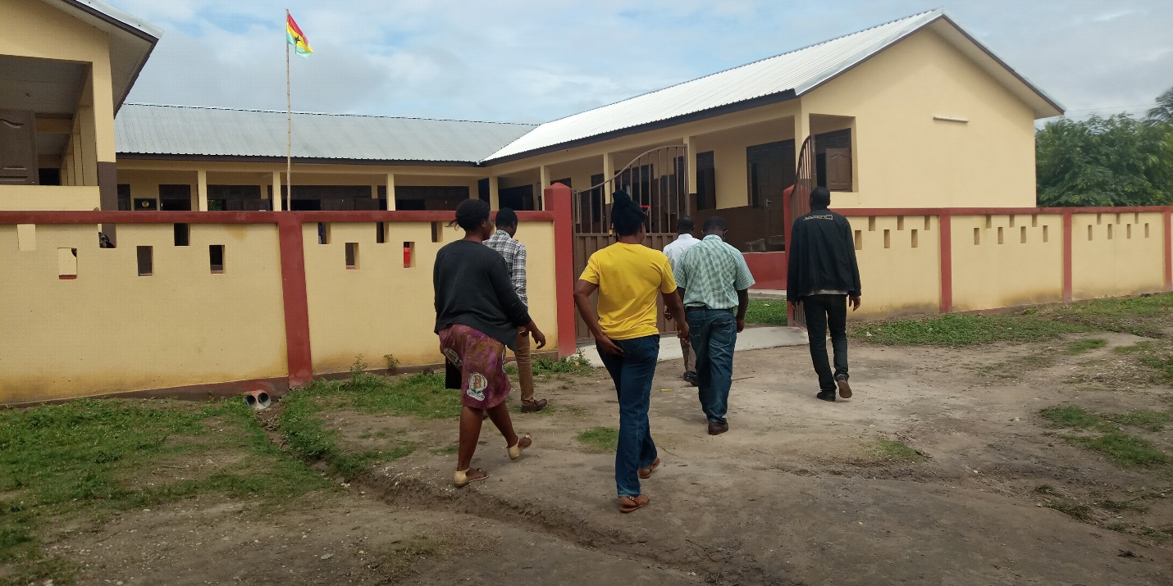
Team Visiting Akutreso school to monitor GIFTS activities

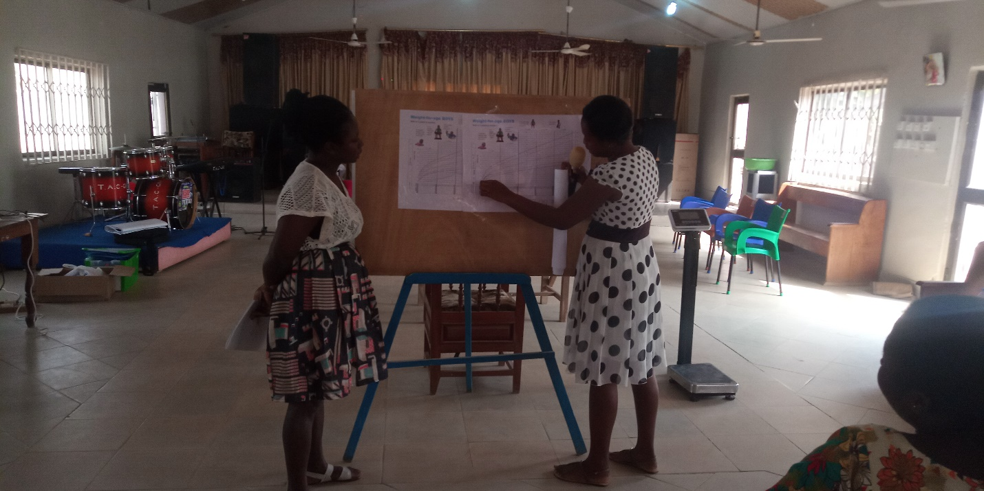
Training of Staff on MCHRB
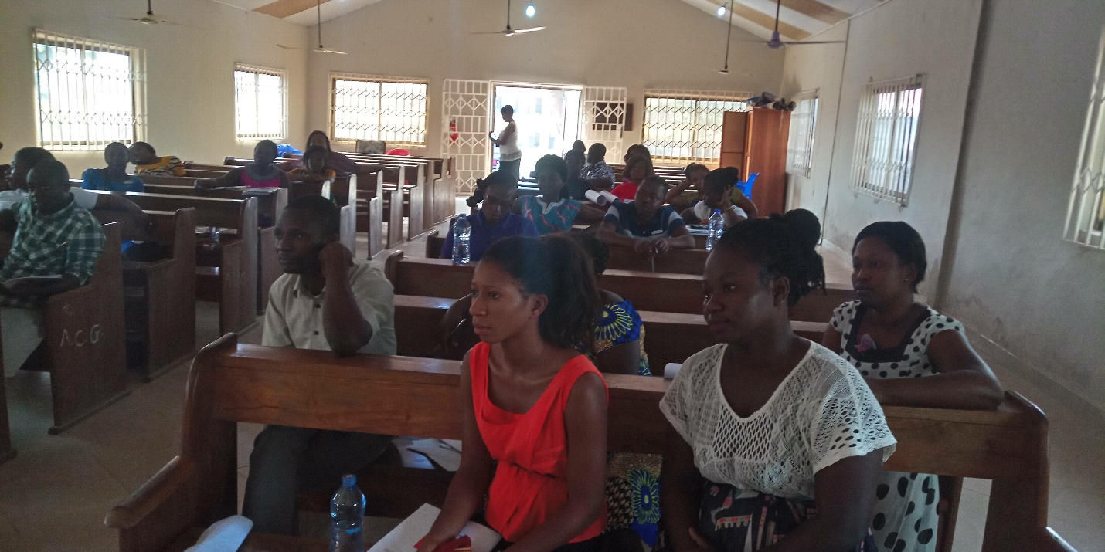
Training of Staff on MCHRB
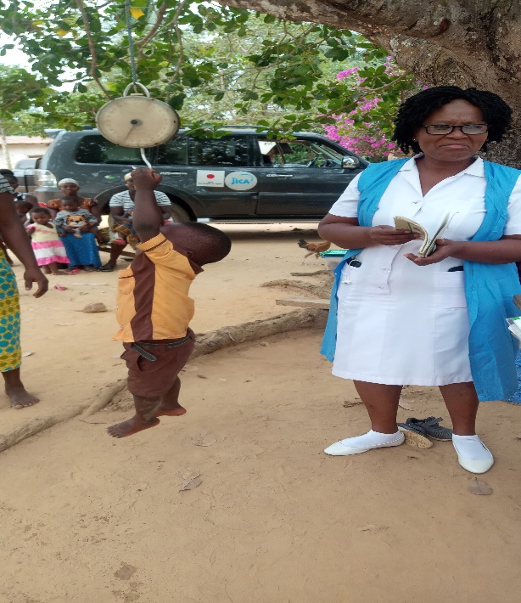
Monitoring on MCHRB

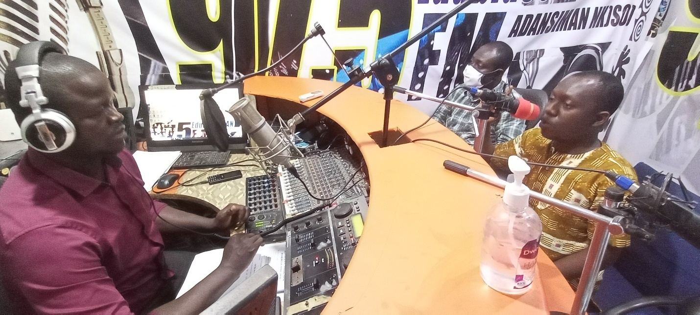
Nutrition education at Edubiaseman FM

