Adansi South District Assembly has provided more COVID-19 items to the communities through the Assembly Members-DCE
The DCE of Adansi South Hon. Francis has disclosed that more items and PPEs to fight the spread of the COVID-19 in the district have been provided to the various communities and institutions through the Assembly Members. He disclosed this at the First Ordinary General Assembly which was held at the Methodist Church Premises at New Edubiase to ensure proper social distance.
Hon. Francis Kwabena Ankomah said that the items consist of veronica buckets with their stands, washing bowls, liquid soap, sanitizer, reusable nose masks, thermometer guns and wheel chairs for the people with disabilities.
He used the occasion to thank the staff of Ghana Health Service for the dedicated services they have been rendering in the mist of this dangerous pandemic.
Presenting the Executive Committee’s report for the period the DCE said that most of the projects inherited from the previous assembly have been completed and handed over to the communities. He disclosed that new projects have been started and are vigorously on going; while others have been completed and handed over. He specifically mentioned the new market and a four units classroom block at Atobiase and another new market at Apagya.
The Presiding Member of the Assembly Hon. Cosmos Amoah also eulogized the hard work of the management of the district assembly and called on all the assembly Members to play their part to support the management to bring development into district.
After deliberating on the Executive Committee’s Report by the Assembly Members, it was adopted as a working document for the assembly.
After the proceedings all the Assembly Members were given sanitizers and face masks thebe giving to the vulnerable people in their electoral areas.
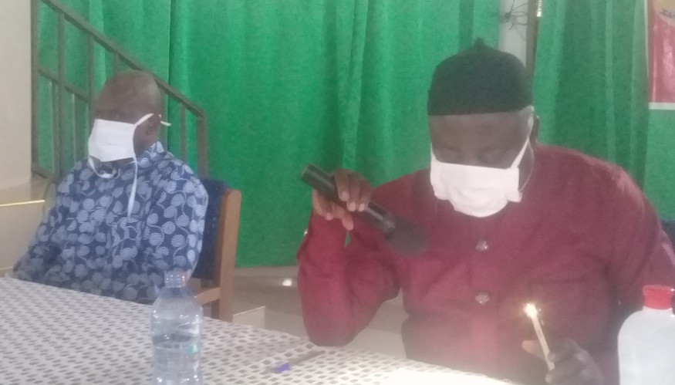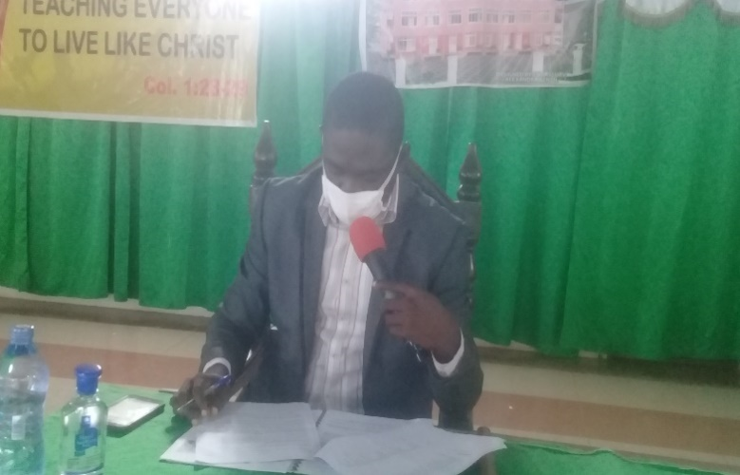
Hon. Francis Kwabena Ankomah, DCE (middle) presenting the Executive Committee’s Report at the First Ordinary General Assembly Meeting and Hon. Cosmos Amoah, PM (right) presiding over the deliberations at the meeting. Extreme left is Mr. William Meledi the District Coordinating Director.
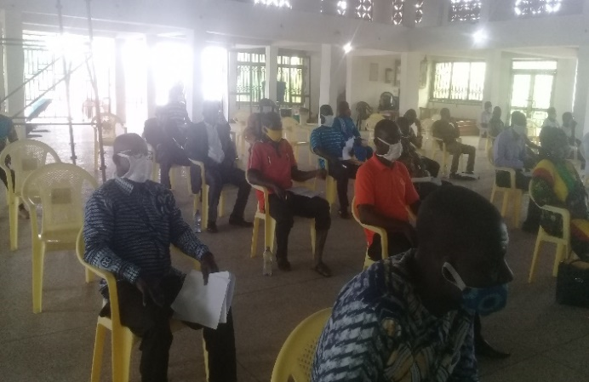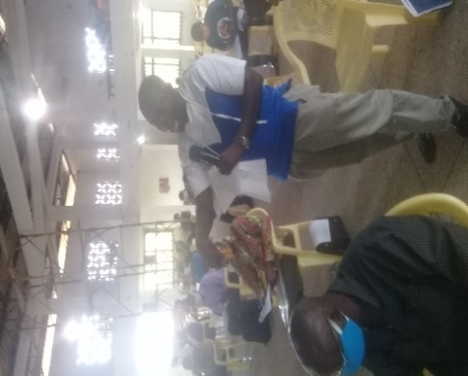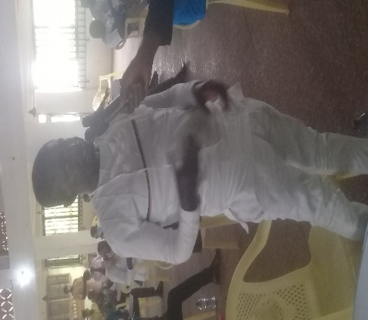
A section of the Assembly Members at the First some of the Assembly Members contributing to the discussions
Ordinary General Assembly Meeting. on the floor during First Ordinary General Assembly Meeting.

BY KUSI-OBUADUM BROBBEY (ISD)

